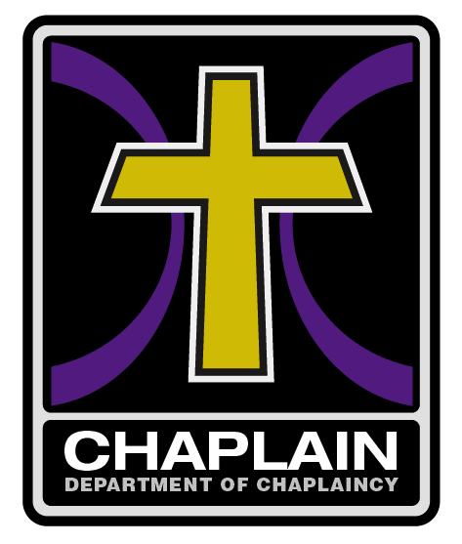

# Pastoral Approval Form

I hereby give ______________________________ my approval and blessing to work as Chaplain.

* I understand that he/she as a chaplain will be working under the direction of the local pastor and church but certified as an UPC Chaplain. In this way we will bring credibility and organization to our chaplains into a connected team within the Department Of Chaplains (DOC)
* I understand that being certified as a UPC Chaplain it does not make the chaplain a minister, a pastor, or in any way bypass the leadership of the local church. Being a chaplain is a tool to aid in the outreach of the local church as well as develop workers for the kingdom.
* I understand that Chaplaincy Ministries reserves the right to revoke any chaplain’s affiliation with DOC at any time. The local pastor signing this document also reserves the right to request revocation at pastor’s discretion.
* One of our goals is that in the event of a disaster we will have working trained chaplains available to represent the UPCI.

Pastor’s signature: __________________________________Date: _________________

Please legibly/clearly print Pastor’s name: _____________________________

We have tested and proven the effectiveness of this ministry by the souls being reached and won to the kingdom. With over 300 UPC chaplains nationwide serving in local churches, please consider being partners with us as we train your chaplain staff. If you could find it in your heart to support us on a monthly basis, please send a donation to Occupational Chaplains Assoc., PO Box 1532, Saltillo, MS 38866

I thank you in advance for your support.

John D Putnam - Director of Operations

William Dillon - Director Emeritus

We would like to help sponsor the chaplain ministry with a donation of:

* ______________________ one time offering
* ______________________ monthly support

Send to:

Chaplaincy Ministries (OCA)

% Brandi Hood Administrative Assistant

PO Box 1532

Saltillo, MS 38866

You may contact Brandi Hood at brandihood.oca@gmail.com