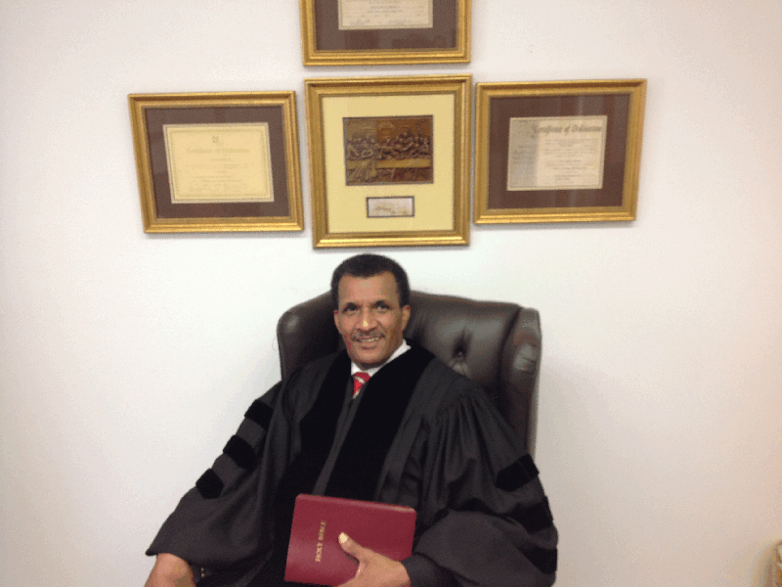

.
The mission of this church shall be to carry out the commands of our Lord Jesus Christ who established the Church (Matthew 16:18). We shall do this by:
- Not forsaking the assembling of ourselves together.
- Observing His ordinances of Baptism and the Lord’s Supper.
- Edifying His people through sound Bible preaching, training and teaching.
- Witnessing for Him and promoting a missionary effort in our community and beyond.
- Spreading the gospel through means of public worship and other suitable means.

